**SSIS:**

1. **Date Dimension:**

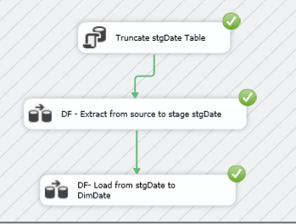

1. **FactCustomerReview:**

**Stage stgFactCustomerReview**

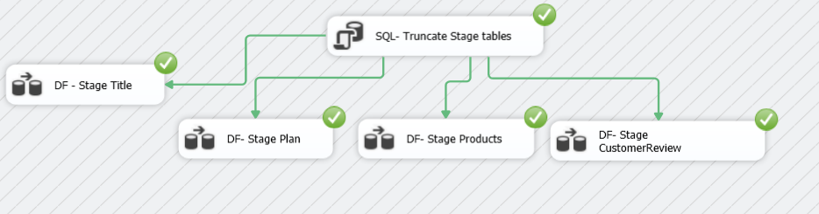

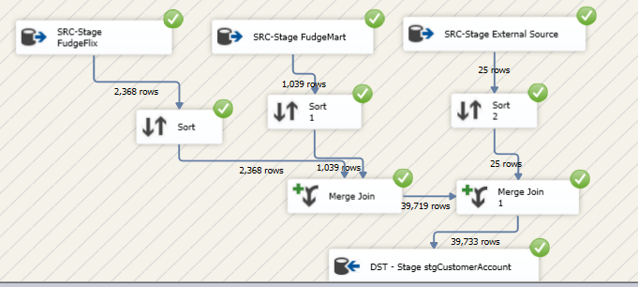

* 1. Stage stgProduct:

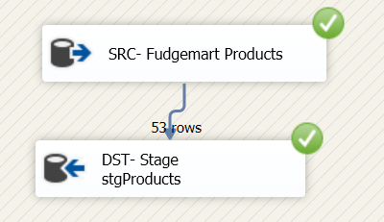

* 1. Stage stgPlan:

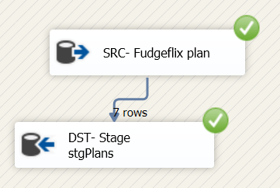

* 1. Stage stgTitle:

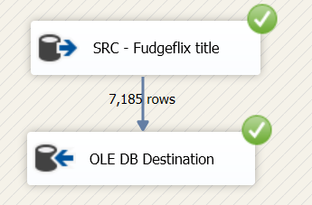

* 1. **DW Customer Review:**

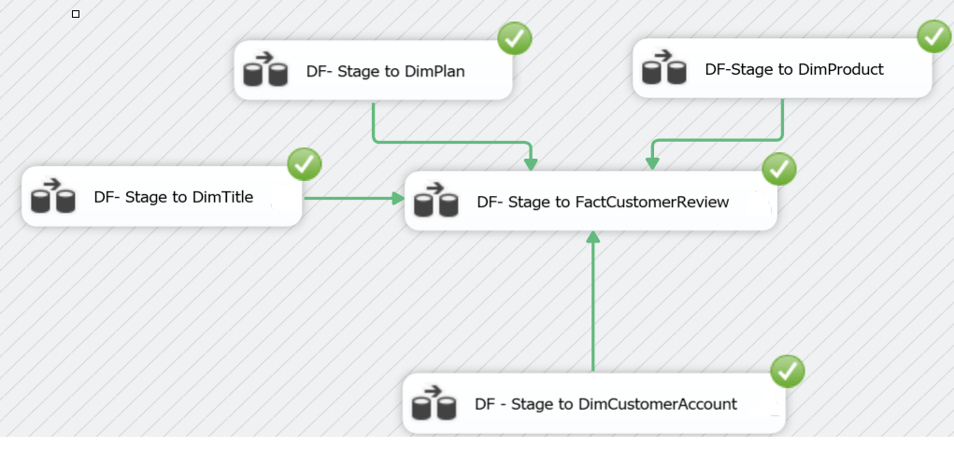

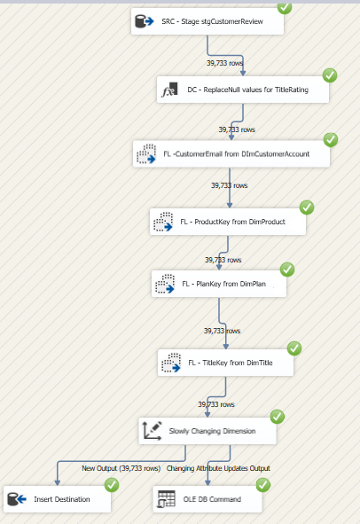

* 1. DimPlan:

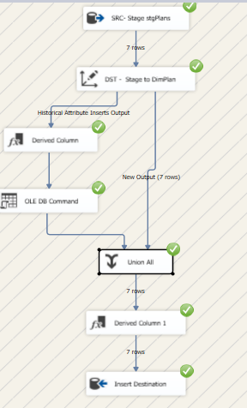

* 1. DimProduct:

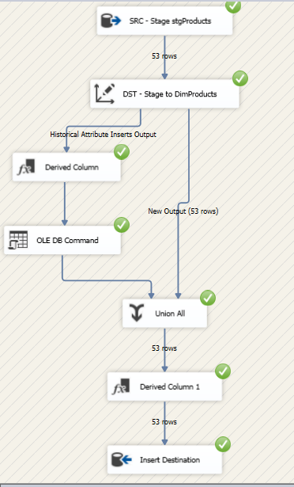

* 1. DimTitle:

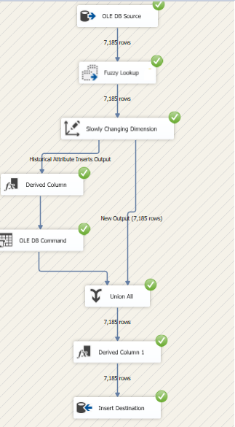

* 1. DimCustomerAccount:

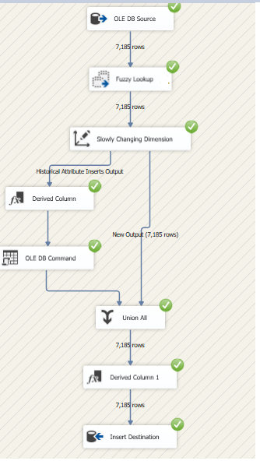

1. **FactDeliveryEfficiency**:
   1. stgAccount:

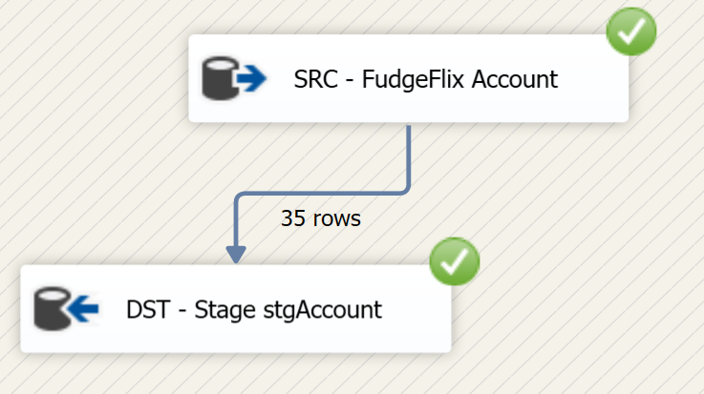

* 1. stgDeliveryEfficiency:

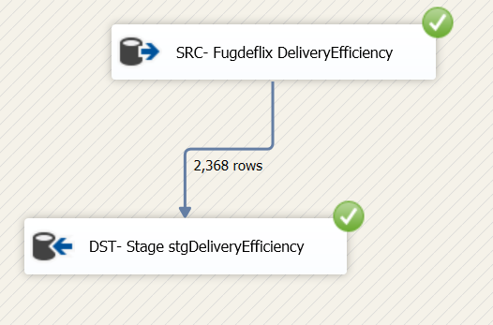

* 1. FactDeliveryEfficiency:

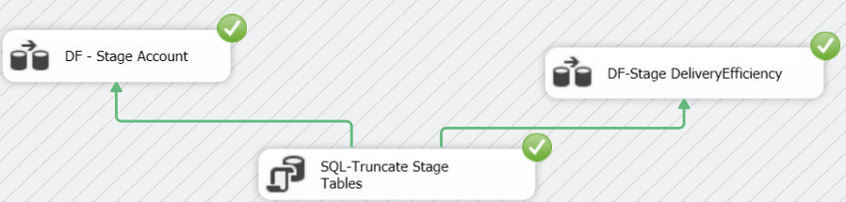

* 1. **DW DeliveryEfficiency:**

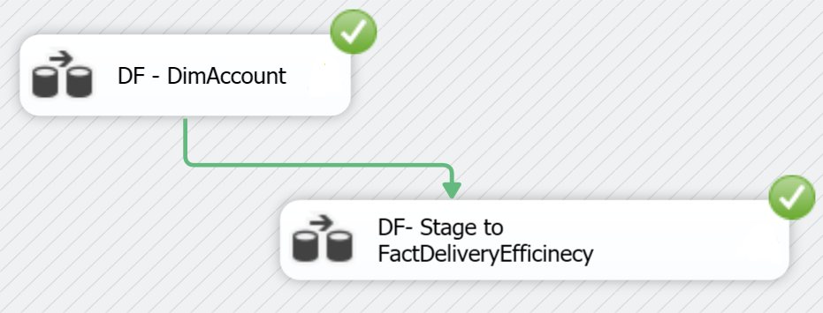

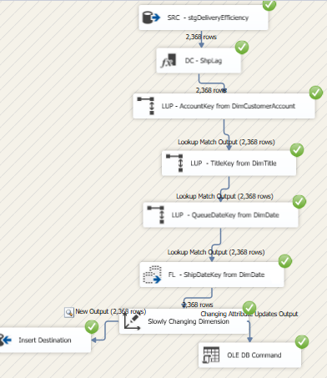

* 1. DimAccount:

